Bilkent University

**Object Oriented Software Engineering Project**

*Project short-name: Mr.&Mrs. Pac-Man Ext.*

*Design Report*

Ecem İLGÜN, Aziz Osman KOZHAN, Başak Şevval EKİCİ, Talha ŞEKER

Supervisor: Bora Güngören

Progress Report

Oct 21, 2017

This report is submitted to the Department of Computer Engineering of Bilkent University in partial fulfillment of the requirements of the Object Oriented Software Engineering Project course CS319.

**Contents**

**1. Introduction** **1**

**1.1 Purpose of the System** **1**

**1.2 Design Goals** **1**

1.2.1 End User Criteria 1

1.2.2 Maintenance Criteria 1

1.2.3 Trade-offs 2

**2. Software Architecture** **3**

**2.1 Subsystem Decomposition** **3**

**2.2 Hardware/Software Mapping** **4**

**2.3 Persistent Data Management** **5**

**2.4 Access Control and Security** **5**

**2.5 Boundary Conditions** **5**

**3. Subsystem Services** **5**

**3.1 GUI Layer** **5**

**3.2 Game Logic Layer** **6**

**3.3 Data Layer** **6**

**4. Low Level Design** **6**

**4.1 Object Design Trade-offs** **6**

**4.2 Final Object Design** **9**

**4.3 Packages** **10**

4.3.1 User Interface Package 10

4.3.2 Game Logic Package 16

4.3.3 Data Package 24

**1. Introduction**

**1.1 Purpose of the System**

Mr.&Mrs. Pac-Man Extended is 2D arcade game which is based on classical Pac-Man game. Therefore, the main purpose of the game is to eat all food on the map without colliding with ghosts. In addition to that, our game has new features such as new food, shield option and creating your own map. By these new features, interest of players will be sustained. This system will be constructed by considering object-oriented design techniques

**1.2 Design Goals**

The main purpose of a game is to entertain player(s). To do that, throughout the project, we have to focus on details which do not directly have an effect on the system. Moreover, with the help of object-oriented design, we aim making a project which is easy to extend. This part details the design goals of the system such as end user criteria, maintenance criteria, performance criteria and trade-offs.

**1.2.1 End User Criteria**

Usability: From user’s perspective, a game should be easy to use and learn. To provide this, we do not change commonly used keyboard buttons to move Pac-Mans. First user plays with arrows and other one plays with W, A, S, D combination. Additionally, the purpose is to avoid confusing GUI design; therefore, GUI will have simple design. On the main menu, there is help section to adapt user to new features. User can realize what to do with suitable icons and prompts. Shield, pause and help panel will appear as pop-up for simplicity. Therefore, user does not have to pass windows each time.

Performance: For a good game experience, we try to overcome input lags and low fps. For example, user can hit a ghost due to keyboard input lag and this is frustrating. To achieve this, we focus on writing code as efficient as possible. The game is chosen to be applied in a 2 dimensional world not to experience rendering problems.

**1.2.2 Maintenance Criteria**

Extensibility: The game is designed in a way that allows developers to add new features and components to meet the user expectations. If deemed necessary, new shields, food or ghosts can be added. For now, two players can play the game locally; however, in the future, number of players can be incremented. All of these are beneficial for player experience.

Modifiability: The system designed will be centered around a multi layered architecture. We have chosen three-tier architecture: Presentation tier includes user interface parts, logic tier makes logical decisions and calculations, and data tier stores and fetches data. Adapting three-tier architecture model allows us to modify each subsystem easily, without affecting any of the remaining ones.

Reusability: Subsystems can be used in other games or similar systems because the system is designed adhering to multitier architecture. Therefore, subsystems can carry out their functionality with other subsystems.

Portability: We have chosen to implement the game in Java. Java provides Java Virtual Machine (JVM) which is runnable in many operating systems. This feature of Java increases portability of the game.

**1.2.3 Trade-Offs**

Portability – Performance & Memory: In this project, we will use Java programming language which is runnable in many operating systems. This decision results in increased portability of the game.

However, it also means that Java will first compile the program into byte code and then has to call its interpreter, Java Virtual Machine, to interpret the code into machine code. Including this middle process in machine code generation, namely using JVM, may incur in performance penalty.

A second trade-off occurs in memory usage. Java's object model requires a lot more space. For instance, it makes use of wrapper classes for some of the basic types in C++ (e.g. int vs Integer wrapper class). These wrapper classes carry the overhead of an Object class.

Therefore, Java uses more resources and makes less function with more code compared to C++.

Functionality – Usability: At first glance, new features decrease usability. With each new feature, user encounters something different from the basic Pac-Man game and getting used to new features takes time. Therefore, since we have aimed to decrease orientation time of a new user, there will not be too much functionality which might cause confusion. However, the game might be quite boring without new features. This made us to add the new features mentioned in 'Purpose of the System'.

As a result, our purpose was to reach a middle ground between functionality and usability. We have added new features to increase functionality, but have refrained from making the game logic or the UI too complicated for the user to play/get used to.

Reusability – Performance: Multitier architecture will be followed to increase reusability of the system and its components. However, this design increases function calls; therefore, our choice of architecture will have a negative effect on overall performance.

**2. Software Architecture**

In this part, we will examine composition of our system. As it has been mentioned before, the system will be constructed by smaller subsystems. In this way, we can prevent huge chunk of codes and codes can be ordered systematically. In our project, we will use Model View Controller (MVC) design which is suitable for this kind of game project.

**2.1 Subsystem Decomposition**

In this section, we will demonstrate subsystems roughly. Detailed information about subsystems is in third chapter. While deciding subsystems, we aim loosely coupling each system and followed three-tier architectural style. Throughout the project, some code blocks will need to be changed; therefore, we do not couple subsystems strictly. Otherwise, all subsystems are affected due to a change in one subsystem. Additionally, such a design is beneficial to develop the game in the future. Briefly main concerns are modifiability and extensibility. Our system consists of three subsystems: GUI Layer, Game Logic Layer and Data Layer

* GUI Layer will have classes which is responsible for providing user interface and having interaction with user.
* Game Logic Layer will carry out all decisions and calculations.
* Data Layer will be responsible for protecting data about high scores and maps.

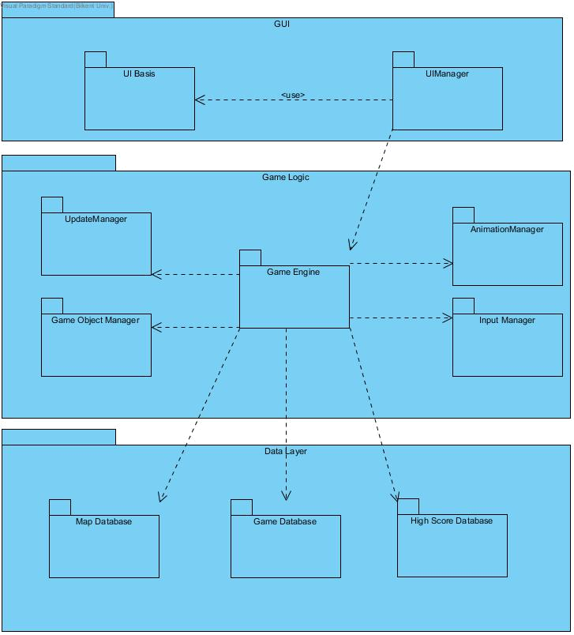

*Figure 1*

**2.2 Hardware/Software Mapping**

Our game will be implemented by using Java programming language. All user interface and graphics components will be constructed by using Java libraries. Most computers can run this game because it does not contain any 3D rendering and intense calculations. Our game requires a bit of memory because in data tier layer the system will make some operations such as saving high scores, map and game. To give inputs, basic mouse and keyboard will be enough. Due to these simple hardware and software

requirements, this game is runnable in many computers and in many operating systems such as Windows, Linux and mac.

**2.3 Persistent Data Management**

In our game high scores, created map and current position of a game level are persistent identity that needs to be stored after each game. We will use local database for all of them because our game will not have any network connection. It means that user can only see high scores which obtained his/her own computer. By using file system, data will be written into txt. files.

**2.4 Access Control and Security**

Our game does not require any authentication or account because all data stored locally and do not require any private information from user. Therefore, the project does not require any access control or security.

**2.5 Boundary Conditions**

Execution

Mr.&Mrs. Pac-Man will be launched by double clicking .jar file of the game. The game does not need any special software other than Java Runtime Environment.

Termination

Scenario 1: Player clicks exit button on the pause menu.

Scenario 2: The game can be terminated by using Alt+f4 combination or clicking X icon on the window (for Windows).

Failure

Scenario 1: If there is an error with database system, a prompt will be appeared and user will not be able to save what s/he wants to save.

Scenario 2: If electricity or computer problem happen, the game will not give any opportunity to save the last situation. The user will lose all progress.

**3. Subsystem Services**

In this section, there are detailed expressions of subsystems.

**3.1 GUI Layer**

GUI Layer contains all user interface components. These components will be contained in user interface package. In this package, there will be main menu screen, help screen, pause menu screen, high scores screen, create map screen, game over screen, game screen, shield panel and name request screen.

If user clicks play game, game screen will be activated and GUI Layer and Logic Layer will communicate with each other to carry out logic. If first or second level is achieved, shield panel will appear as pop-up and again these two layers interact. If user saves a map, Logic Layer interacts with Data Layer to store the map.

**3.2 Game Logic Layer**

Game Logic Layer is responsible for carrying out main dynamics of the game. The main class of this layer is GameEngine class. GameEngine class is responsible for implementation of game preparation, start game, pausing and saving game. It also controls and holds level, number of players, score and number of lives Pac-Mans. GameEngine executes main processes; however, while doing that, it uses some helper subsystems. One of them is InputManager system which provides interaction between user and GameEngine. InputManager takes arrow keys; W, A, S, D combination and Esc key as input. Another significant subsystem is UpdateManager which provides a basis for frame life cycles. UpdateManager is mainly responsible for cycle and object management and action handling. For example, UpdateManager handles the situation where Pac-Man hits a ghost. Another subsystem is AnimationManager which handles all the animation related cases of game such as movement animation of Pac-Man.

**3.3 Data Layer**

Data Layer contains high scores database, map database and current game database. Map database saves created maps and names. High scores database saves high scores and names. Current game database saves last situation of a saved game.

**4. Low Level Design**

**4.1 Object Design Trade-Offs**

Designing the objects need some principles applied in order to get rid of the possible bugs in the program and also make the program in the most efficient way. In game, we design the objects in a reusable way to deal the complexity. We also keep the data background in an uncompressed form and this leads to a space-time tradeoff.

**4.1.1 Reusability of the Objects**

The program is divided into three layers, which are complex subsystems itselves. The subsystems are connected in suitable forms and there is a hierarchicy in between the classes.

**4.1.1.1 Inheritance**

Using inheritance between classes had reduced the complexity of the program and the amount of code would have written. Extending helps to have the main properties and abilities of the super class and use them in another object, which is based on the super class but formed in a more complex and specific object. For example in the game, the game panel designed in a grid form so that every object needs to have coordinates, an image of the character etc. So we created a Pacman Object that will be a base to every character object in the game. For example Pacman is extended to the Pacman Object, but has characteristic methods and properties (Figure 2). The PacmanObject class is the base class for every object; which will use in the game. From food to brick all the screen objects share some basic set of properties and the PacmanObject class helps to not write these properties to every object again and again.

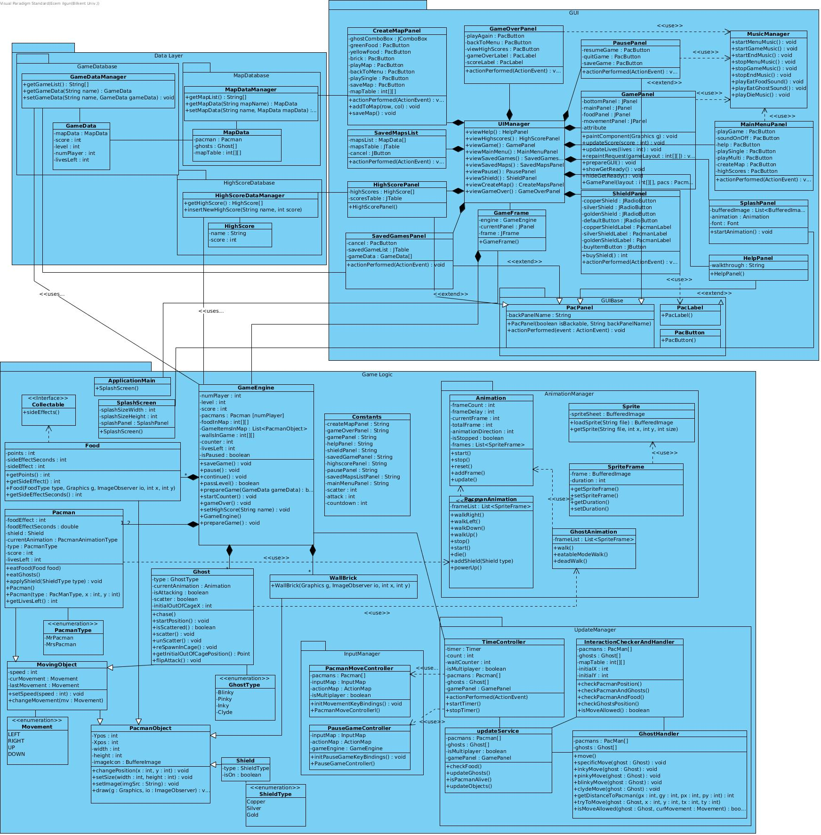

*Figure 2*

**4.1.1.2 Interface**

To have a reusable object design, interfaces are an essential component of the system. It helps decoupling separate components of the program and provides a polymorphic behavior. The usage of interfaces in our program is good for breaking up the complex designs. Although Java interfaces are slower and more limited than the other ones, using interface clarifies the dependencies between the classes of the game. In figure 2, it can be seen that the class Food uses an interface Collectable, which is also used by the Food-extended classes such as Yellow, Green or Big Food.

**4.1.1.3 Polymorphism**

Polymorphism is another important object oriented programming concept that we had used in our game. It allows the game objects to take on many forms. We used polymorphism in our project and by overriding the methods of parent class we were able to call the same method for all children of that class.

**4.1.1.3 Collapsing Redundant Classes**

We have also collapsed some classes we have identified during the first iteration. GreenFood, YellowFood and BigFood classes have been collapsed into a generalized food class, and their respective differences are now different values in Food classes attributes (i.e. each different type of food have different score points, but these points are points attribute of Food class, no matter what type the food is). This helped us reuse the same class for each different implementation we had previously foreseen.

**4.1.2 Space-Time Trade-Offs**

Data storage brings some problems with itself. In our program, the storage method caused the tradeoff. We store the data of the game in an uncompressed way, which takes more space. But by not compressing data, the program does not run the decompressing algorithm and the program runs in less time, which is more practical in our case. To reduce the transmission time and so the cost at the expense of CPU time to perform the compression and decompression, we used the uncompressed form of the data.

**4.1.3 Encapsulation**

Programmers use encapsulation to prevent clients accessing program data when there is no need. Hence, we can prevent possible bugs. However, performance of the system is negatively affected due to extra procedures as a trade-off. To implement encapsulation, we made all attributes and operations which should not been accessible and not necessary to be accessed by client private.

**4.2 Detailed Object Design**

Detailed class diagram showing GUI, Data Layer and Game Logic subsystems is provided in the next page in order to provide an overlook of the project.

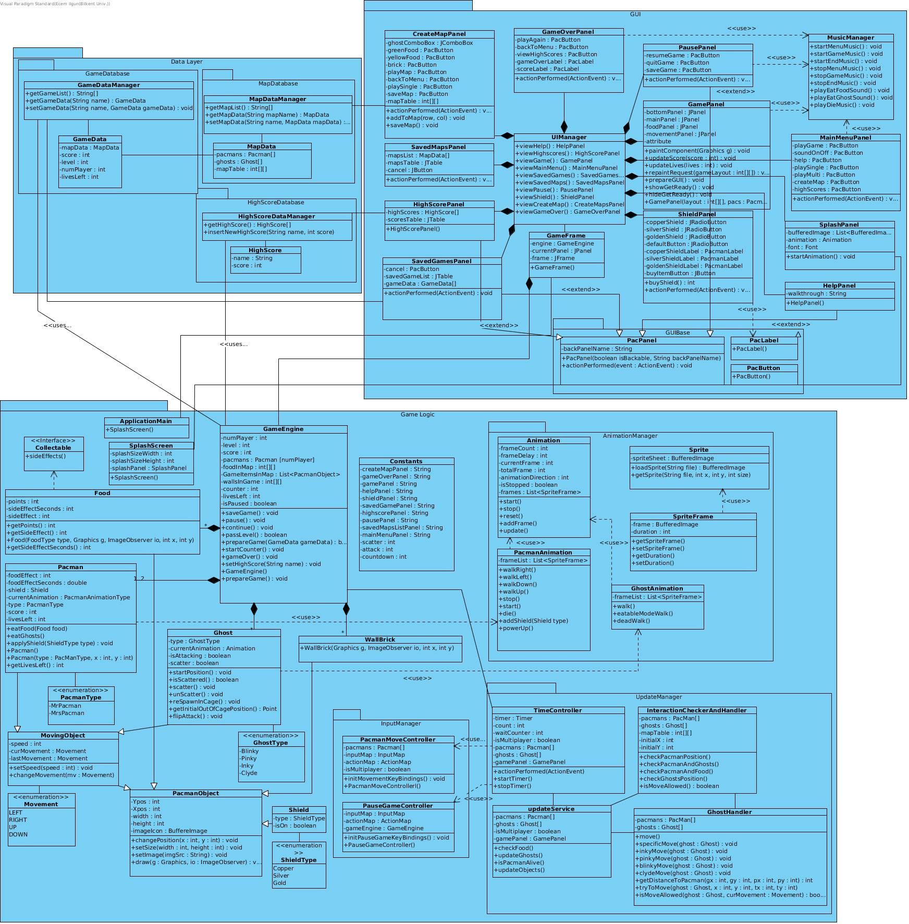

*Figure 3 – Object Design Diagram*

*go to* [*https://github.com/talhaseker/Mr.-Mrs.-Pacman-Extended/blob/master/Diagrams/ClassDiagrams/classDiagram_designReport_iteration2.jpg*](https://github.com/talhaseker/Mr.-Mrs.-Pacman-Extended/blob/master/Diagrams/ClassDiagrams/classDiagram_designReport_iteration2.jpg) *for better resolution*

**4.3 Packages**

**4.3.1 GUI Package**

This package is used to provide our subsystem with graphical components, including the game frame and its panels, which are used to provide the user a different screen for each scenario mentioned in our analysis report.

The package includes two crucial classes: UIManager and GameFrame.

UIManager is GUI Package's *service class* which provides GameFrame with any kind of panel the user input may require, e.g. GameOverPanel will be invoked if user fails the game. GameFrame, the other crucial class, includes an instance GameEngine and a currentPanel which will be initialized to the panels provided by UIManager. It is the *core class* of GUI Package. It is used to interact with the Game Logic layer (via GameEngine), which is analized in the next section (4.3.2).

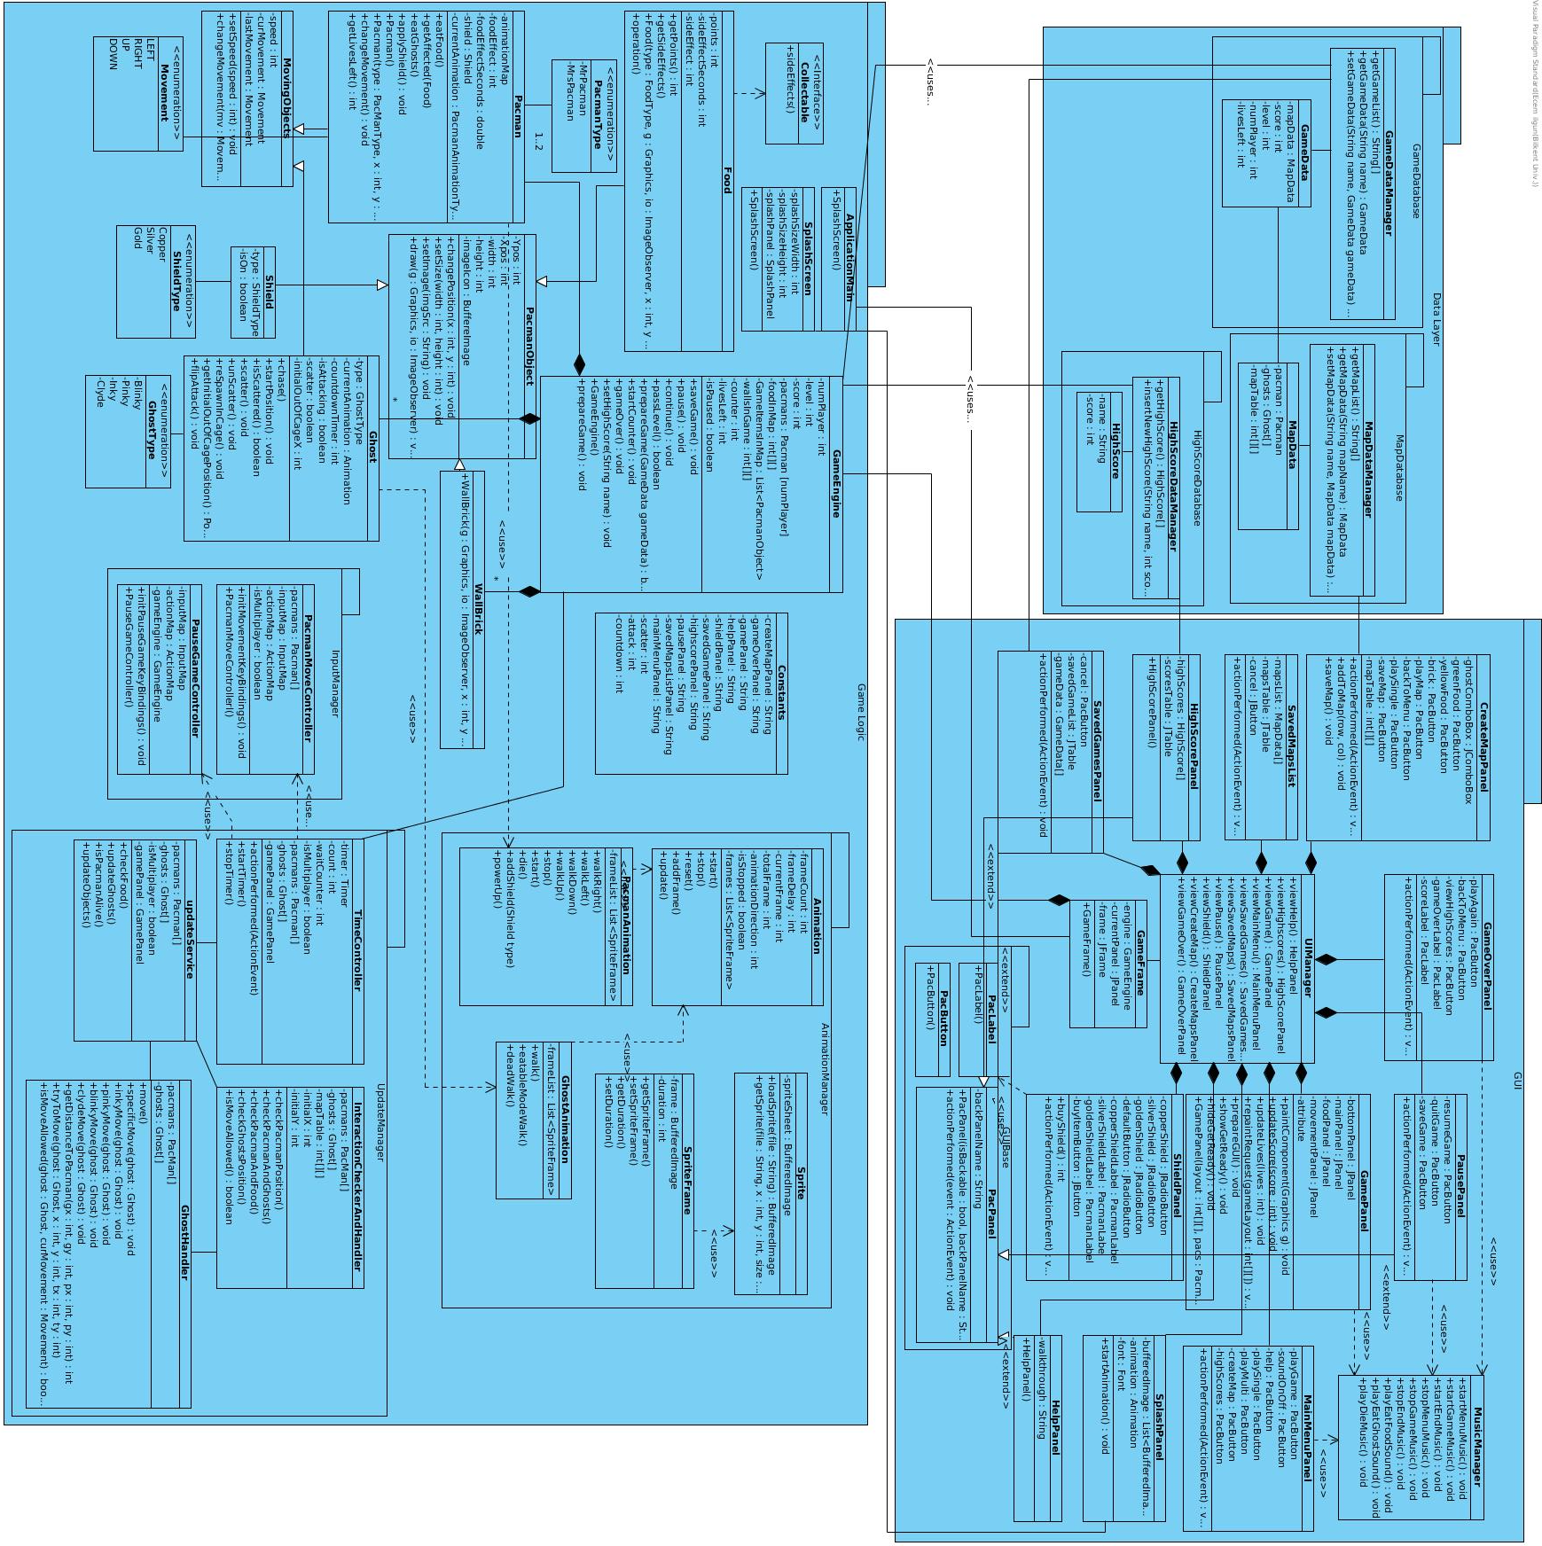

*Figure 4 – Graphical User Interface Package*

**4.3.1.1 GameFrame Class**

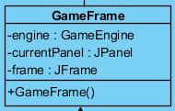

*Figure 4.1 – GameFrame Class*

**Attributes:**

private Jframe frame: This frame is used to display all visual context of our game.

private GameEngine engine: GameFrame class uses this GameEngine instance to interact with the Game Logic subsystem when user selects to play the game. Game Logic subsystem controls all decisions regarding the game, takes keyboard inputs and updates each game logic object.

private currentPanel JPanel: currentPanel will hold one of the panels provided by UIManager methods.

**Constructor:**

public GameFrame(): This is called each time a GameFrame object is initialized.

* + Initializes frame, currentPanel and engine.
  + Calls UIManager.viewSplash(). This method sets currentPanel to SplashPanel.
  + Calls UIManager.viewMainMenu() after intro animation ends. This method sets currentPanel to MainMenuPanel.

**4.3.1.2 UIManager Class**

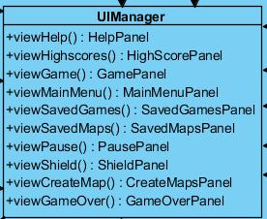

*Figure 4.2 – UIManager Class*

**Methods:**

protected HelpPanel viewHelp(): The purpose of the method is to show a help panel when the user clicks the button. It creates and returns a HelpPanel.

protected HighScorePanel viewHighScore(): This method aims to show the player the high score table when he/she clicks related button. It asks for HighScoreDataManager class to provide it with high scores. Creates a HighScorePanel instance and returns it.

protected GamePanel viewGame(): This method is for bringing the game panel, which includes the game items, to screen when related button is clicked. It calls GameEngine.prepareGame() to change GameFrame's engine attribute. It creates a GamePanel instance and returns it.

protected MainMenuPanel viewMainMenu(): The purpose of the method is to show main menu screen which has the options and buttons. It creates a MainMenuPanel instance and returns it.

protected PausePanel viewPause(): This method is for screening the pause game options and stopping the game until user prefers to keep playing. It creates a PausePanel instance and returns it.

protected CreateMapPanel viewCreateMap(): This panel aims to screen the building map part of the game. If the user demands to create his or her own map, the method creates a CreateMapPanel instance and returns it.

protected ShieldPanel viewShield(): When player passes to the next level, this method shows a shield panel by basically creating a ShieldPanel instance and returning it.

protected SavedGamesPanel viewSavedGames(): When the user wants to play one of the saved games, the saved game screen is being showed by the method. It asks for GameDataManager class to provide it with a list of saved games. It creates a SavedGamesPanel instance and returns it.

protected SavedMapsPanel viewSavedMaps(): If the user clicks the button of saved maps in the main menu to play a map he or she previously made and saved, the method shows the menu for the saved maps. The method asks MapDataManager class to provide it with a list of saved maps and it creates a SavedMapsPanel instance and lastly it returns the instance.

protected GameOverPanel viewGameOver(): When the player is out of live or It creates a GameOverPanel instance and returns it.

protected SplashPanel viewSplash(): It creates a SplashPanel instance and returns it.

**4.3.2 Game Logic Package**

Game Logic Package is responsible for handling all of the game mechanics.

We have grouped various kinds of PacmanObject's children (Food, Pacman, WallBrick, Ghost and Shield) each with its own attributes inside this package. Therefore, all data of the game while the game is still running is handled inside Game Logic package.

We have also grouped service classes which will change these PacmanObjects inside the Game Logic Package. Therefore, Game Logic Package is also responsible for updating each objects status and position according to manager subpackages: InputManager, UpdateManager and AnimationManager.

Core class of Game Logic Package is GameEngine class, which controls all of the updates each PacmanObject will receive. GameEngine will share the information it has with GUI subsystem as mentioned in the previous section (4.3.1).

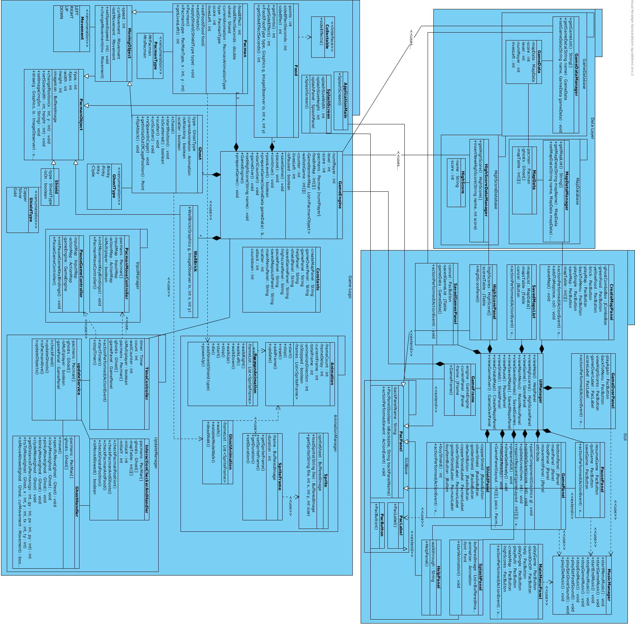*Figure 5 – Game Logic Package*

**4.3.2.1 GameEngine Class**

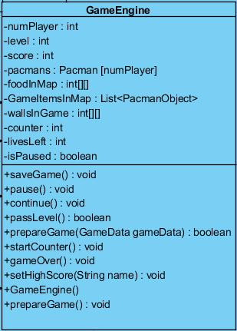

*Figure 5.1 – GameEngine Class*

**Attributes:**

private int numPlayer: Keeps number of players in the game.

private int level: Keeps the current leves user is in, or was in in if user loads a saved game.

private int score: Keeps the sum of the scores reached by user(s) in that game.

private Pacman[numPlayer] pacmans: Keeps 1 or 2 pacman instances, depending on whether the user has chosen single or multiplayer modes.

private int[][] foodInMap: Keeps a 2D map of integers where each element will correspond to a grid and the integer value inside each element will determine whether the grid has a food and if so, the food's type.

private List<PacmanObject> gameItemsInMap: Keeps different kinds of PacmanObjects.

private int[][] wallsInGame: Keeps a 2D map of integers where each element will correspond to a grid and the integer value inside each element will determine whether the grid has a wallBrick.

private int counter: It keeps the number of seconds left until the game starts each time it's paused. It is initialized to 3 seconds inside GameEngine's constructor.

private int livesLeft: Keeps number of lives the player(s) has left in total. It is decremented each time user collides with a Ghost which is in its default chase mode.

private boolean isPaused: It is False while game is Running, True while the PausePanel is active. Also True as long as the countdown until game starts has not

finished yet.

**Constructor:**

public GameEngine(): Initializes each of its attributes to their defaults values.

* + Initializes numPlayer to 1.
  + Initializes level to 1.
  + Initializes score to 0.
  + Initializes pacmans to Pacman array of length 1 with a Mr. Pacman inside.
  + Initializes foodInMap according to default game map.
  + Initializes gameItemsInMap according to default game map.
  + Initializes wallsInGame according to default game map.
  + Initializes isPaused to True (since each game starts with countdown).
  + Initializes counter to 3. ( counter is used for countdown from 3 to 0 before the game starts)
  + Initializes livesLeft to 3.

**Methods:**

public void saveGame(): Constructs a GameData object with all of the attributes in GameEngine. Calls DataLayer.GameDataBase.GameDataManager.setGameData() function in order to save this GameData object into our database.

public void pause(): Sets isPause to True. Sets counter to 3, so that game will count down to 3 and then start after pause.

public void continue(): Calls startCounter(). Countdown has now started. Continues the game once startCounter returns.

public void passLevel(): This function is called when all the food in the map is eaten and the user(s) still has at least one life.

* + If level is not 3, increments it.
  + Else, calls setHighScore().

public boolean prepareGame(): This function is called when users pass a level and continue after choosing their shields. It updates the shield choices and sets game map back to its default, returns true if it succesfully does so.

public boolean prepareGame(GameData gameData): This function is called when users choose to play in any different mode other than the default one (default mode is single player, default map, starting a new game from level one: a.k.a the initialization values). It loads the gameData in order to start a game in a different mode. Returns true if it succesfully loads the data.

public void startCounter(): This function is called in two occasions: if the user starts/loads a game, or if the user continues the game after pause. It makes the game stay paused for 3 seconds and then continue.

public void gameOver(): This function is called if the users have lost their last life. It is first used to inform the GameFrame to display a GameOverPanel, then it calls setHighScore() function.

public void setHighScore(String Player): It calls DataLayer.HighScoreDataBase.HighScoreDataManager.insertnewHighScore() to set a new high score (insertNewHighScore method checks if the new highScore is actually in its top 10 list).

**4.3.2.2 PacmanObject Class**

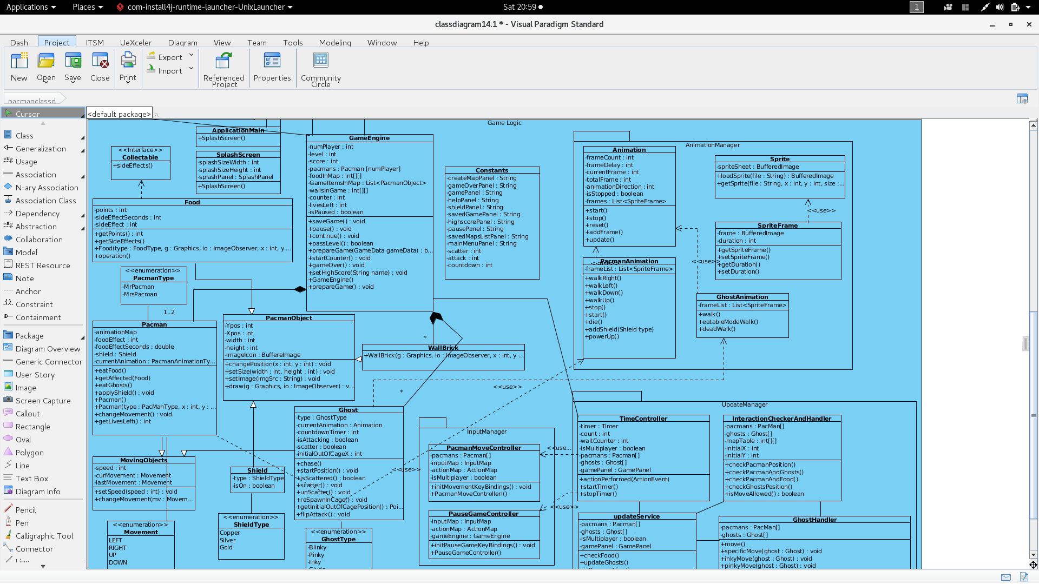

*Figure 5.2 – PacmanObject Class*

**Attributes:**

private int YPos: Keeps vertical location of the center of object.

private int XPos: Keeps horizontal location of the center of object.

private int width: Keep the total width of the object.

private int height: Keep the total height of the object.

**Methods:**

public void changePosition(int x, int y): This function will change Xpos and Ypos attributes of PacmanObject, therefore will affect where the object will be drawn in the next draw method call.

public void setSize(int width, int height): This function will set width and height attributes of PacmanObject.

public void setİmage(String imgSrc): This function will get a source path in its parameter and if the path contains an image, it will set PacmanObject’s imageIcon attribute to the image file in that path.

public void draw(Graphics g, ImageObserver io): When called, this function will draw its imageIcon with respective proportions (xPos, yPos, width and height) in the frame.

**4.3.2.3 MovingObject Class**

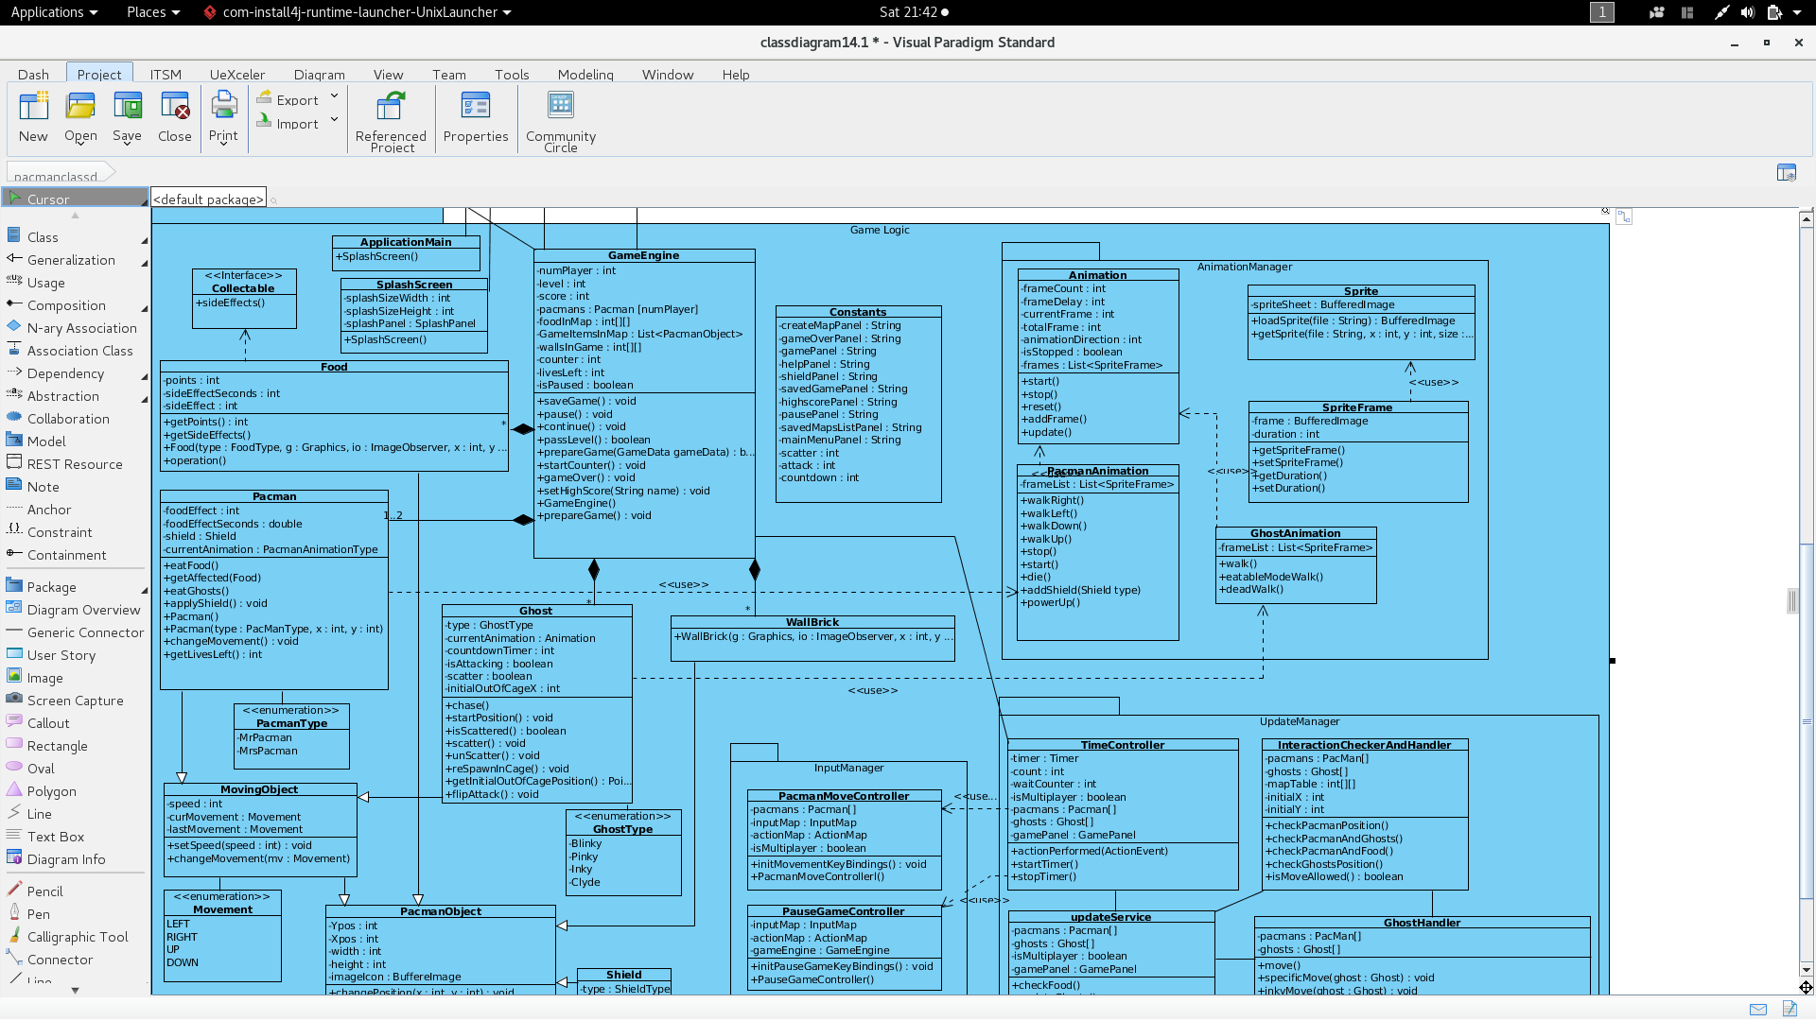

*Figure 5.3 – MovingObject Class*

**Attributes:** MovingObject class has all of PacmanObject's attributes since it inherits fromPacmanObject class.

private int speed: Keeps relative speed of the object as an integer.

private Movement curMovement: Keeps object’s current movement as an enumeration of Movements

private Movement lastMovement: Keeps object’s previous movement as an enumeration of Movements

**Methods:**

public void setSpeed(int speed): Changes speed attribute of the object.

public void changeMovement(Movement mv): Updates movement attributes: Sets lastMovement to curMovement and updates curMovement to mv parameter.

**4.3.2.4 Pacman Class**

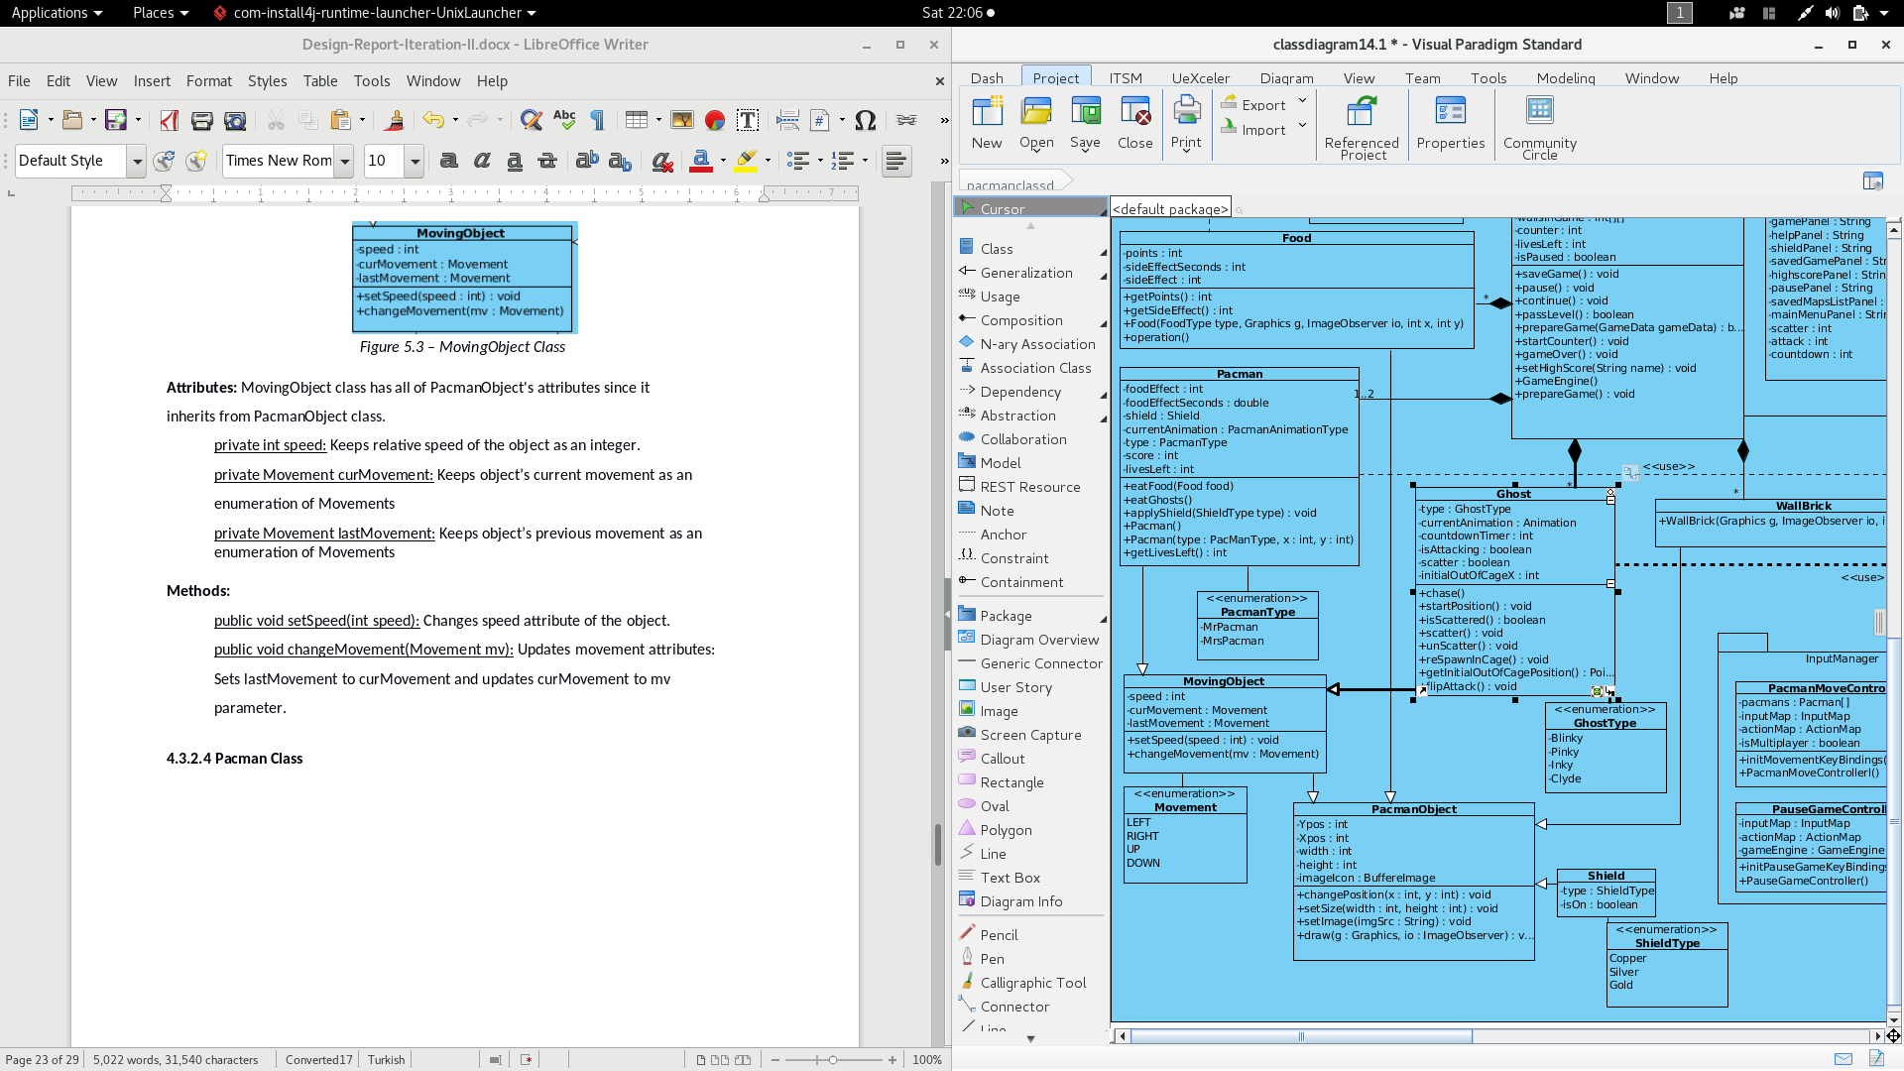

*Figure 5.4 – Pacman Class*

**Attributes:** Pacman class has all of PacmanObject's and MovingObject's attributes since it inherits fromMovingObject class.

private int foodEffect: Keeps an enumeration of foodEffects, it's initialized to 0 if Pacman is not under any effect.

private double foodEffectSeconds: Keeps the amount of seconds left until food's effect decays.

private Shield shield: Keeps the shield if user has purchased one.

private PacmanAnimationType currentAnimation: Keeps an enumeration corresponding to different PacmanAnimation functions.

private PacmanType type: Keeps if Pacman is Mr or Mrs Pacman.

private int score: Keeps score this Pacman has gained (this equals to total score if user plays in singleplayer mode, however sum of both Pacmans will count towards total score if users play in multiplayer mode).

private int livesLeft: Keeps how many lives this Pacman has left.

**Constructors:**

public Pacman(): Initializes each of its attributes to their defaults values.

* + Calls MovingObject to initialize attributes it gets from its parent.
  + Sets its imageIcon (as a PacmanObject) to pacman icon.
  + Initializes foodEffect to 0.
  + Initializes foodEffectSeconds to 0.
  + Initializes shield to null.
  + Initializes currentAnimation to LEFT (of PacmanAnimationType enums).
  + Sets type as Mr.Pacman.
  + Sets score to 0.
  + Sets livesLeft to 5.

public Pacman(PacmanType type, int x, int y): Initializes each of its attributes to their defaults values.

* + Calls Pacman’s default constructor (mentioned above).
  + Changes starting position of pacman with its x and y parameters by setting them to Xpos and Ypos of PacmanObject (Pacman class’ grandparent) respectively.
  + Changes Pacman’s type attributes to type parameter.

**Methods:**

public int eatFood(Food food): This function is called when Pacman object collides with a food object. Pacman object will get affected depending on the food type. It returns the score gained from eating that food type.

public int eatGhosts(): This function is called when Pacman object collides with a ghost in its blueMode. It returns the score gained from eating a ghost.

public int getLivesLeft(): Returns Pacman’s livesLeft attribute.

public void applyShield(ShieldType type): This function is used to update Pacman's shield attribute. It will be called if user buys a shield.

**4.3.2.5 Food Class**

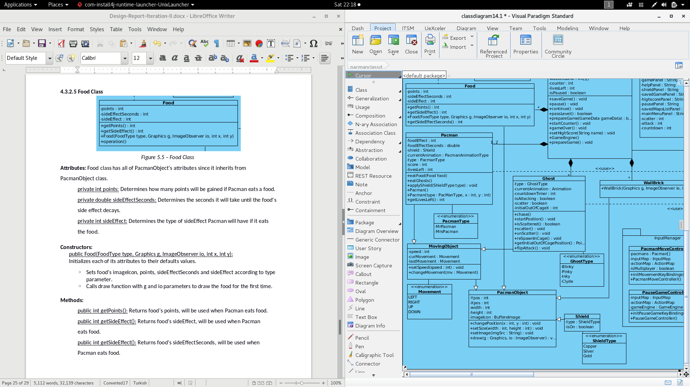

*Figure 5.5 – Food Class*

**Attributes:** Food class has all of PacmanObject's attributes since it inherits fromPacmanObject class.

private int points: Determines how many points will be gained if Pacman eats a food.

private double sideEffectSeconds: Determines the seconds it will take until the food's side effect decays.

private int sideEffect: Determines the type of sideEffect Pacman will have if it eats the food.

**Constructors:**

public Food(FoodType type, Graphics g, ImageObserver io, int x, int y):

Initializes each of its attributes to their defaults values.

* + Sets food’s imageIcon, points, sideEffectSeconds and sideEffect according to type parameter.
  + Calls draw function with g and io parameters to draw the food for the first time.

**Methods:**

public int getPoints(): Returns food’s points, will be used when Pacman eats food.

public int getSideEffect(): Returns food’s sideEffect, will be used when Pacman eats food.

public int getSideEffect(): Returns food’s sideEffectSeconds, will be used when Pacman eats food.

**4.3.2.6 Ghost Class**

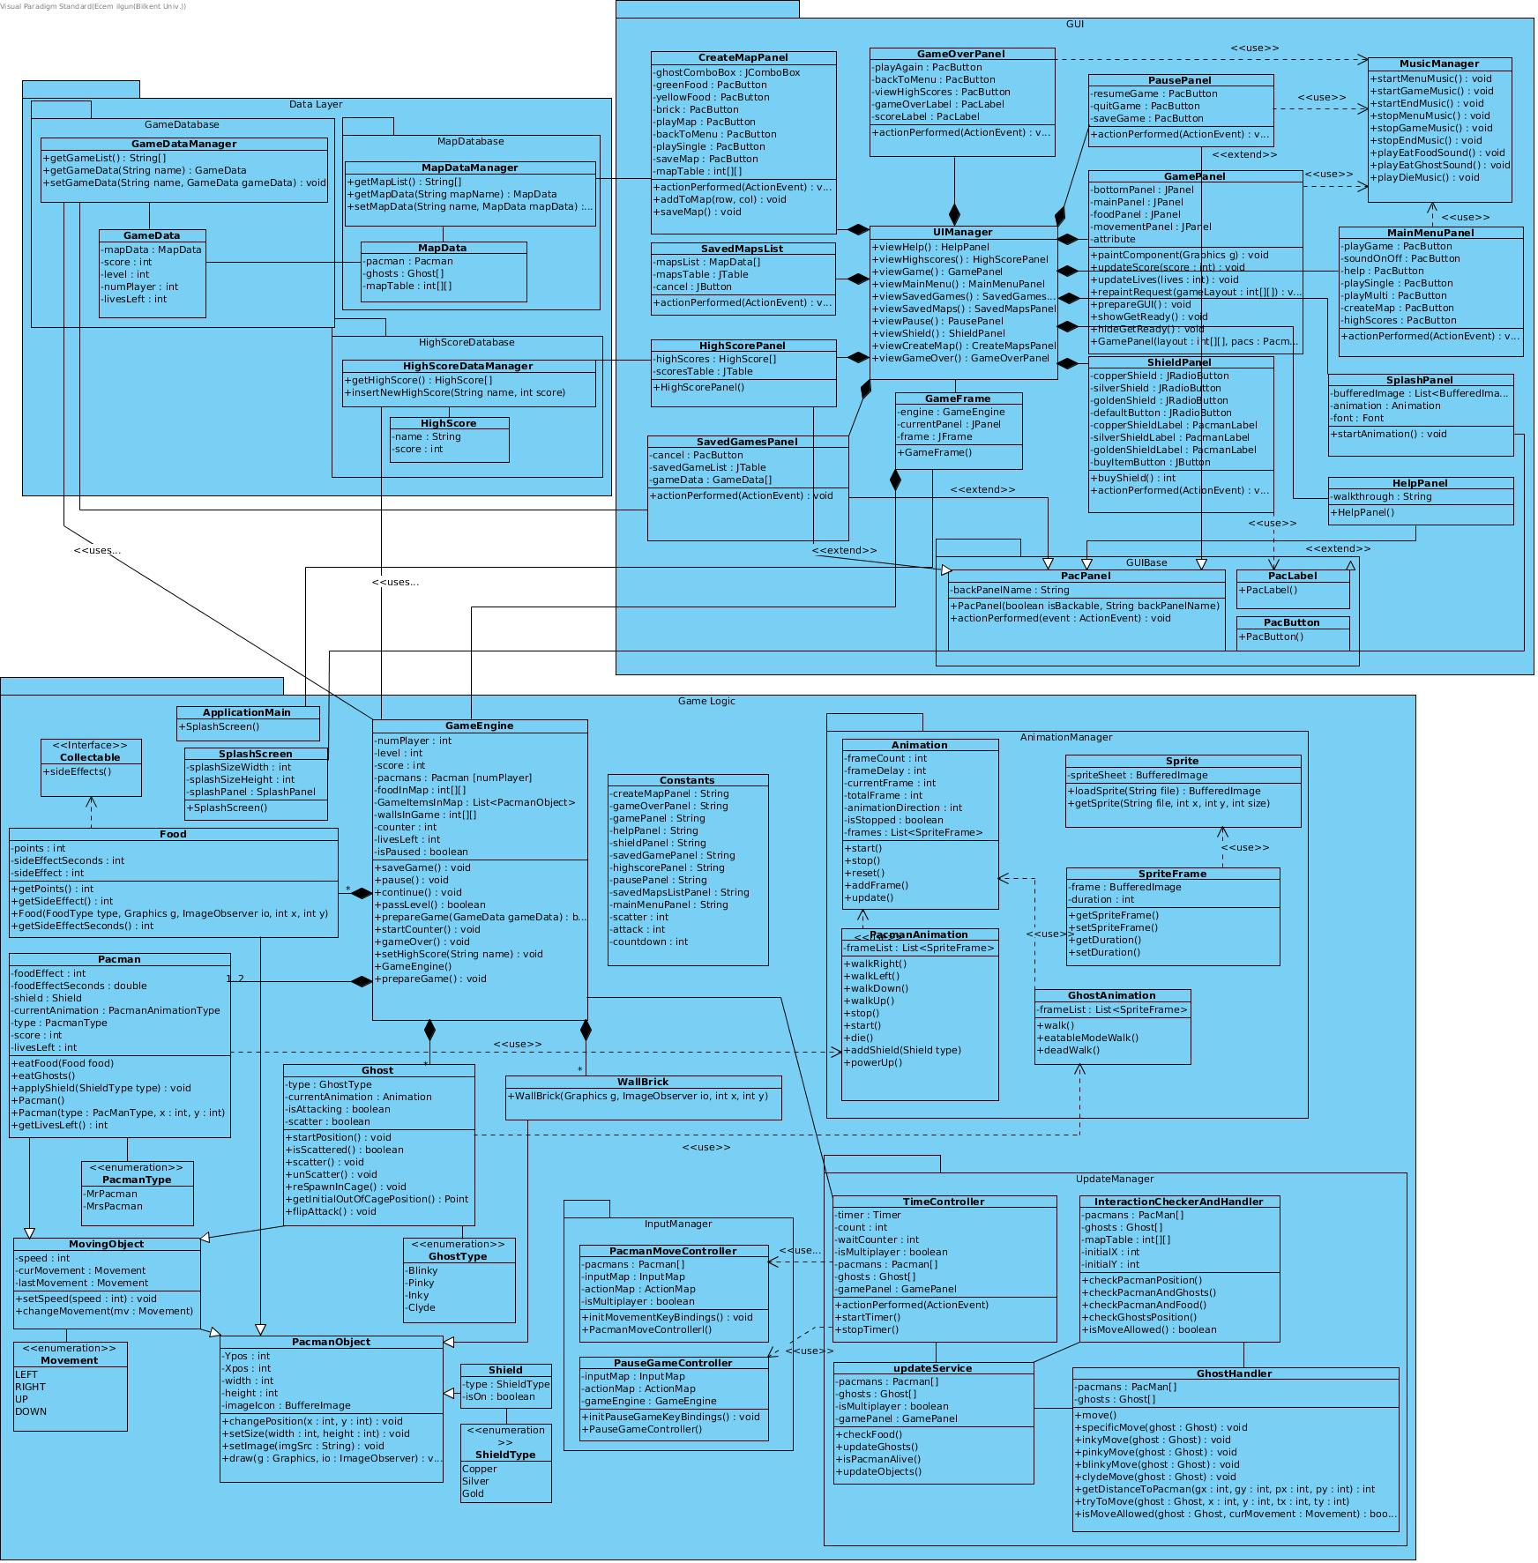

*Figure 5.6 – Ghost Class*

**Attributes:** Ghost class has all of MovingObject and PacmanObject's attributes since it inherits from MovingObject class.

private GhostType type: Determines if the ghost is Blinky, Pinky, Inky or Clyde.

private Animation currentAnimation: Keeps the status of the ghost. Its used to determine its animation. Its also used to determine what happens when Pacman and Ghost collides, e.g. if currentAnimation enum equals to blue mode, then pacman can eat the ghost.

private boolean isAttacking: Keeps if the ghost is attacking or is running away from Pacman.

private boolean scatter: Keeps ghost’s mode, if scatter is false ghosts will try to eat Pacman(s), if true ghosts will try to return to their cage.

**Methods:**

public void startPosition(): This function changes starting Xpos and Ypos attributes of Ghost according to its type.

public boolean isScattered(): Returns scatter attribute.

public boolean scatter(): Sets scatter to true, ghost’s animation will turn blue so that ghost wil try to return back to its cage to return normal.

public boolean unscatter(): This function changes currentAnimation enum to default ghost mode. Also sets scatter to false (the ghosts will chase Pacman).

public boolean respawnInCage(): Changes ghost’s position to out of cage positions, calls unscatter() (unscatter is chasing mode).

public Point getInitialOutOfCagePosition():

public boolean flipAttack(): Changes isAttacking to its complementary boolean .

**4.3.2.7 AnimationManager Package**



*Figure 5.7 – AnimationManager Package*

This package is located inside Game Logic Package since it will only be called from inside of GameEngine to alter some of it's attributes (e.g. to change Ghost's appearance to eatable ghost).

**4.3.2.8 UpdateManager Package**

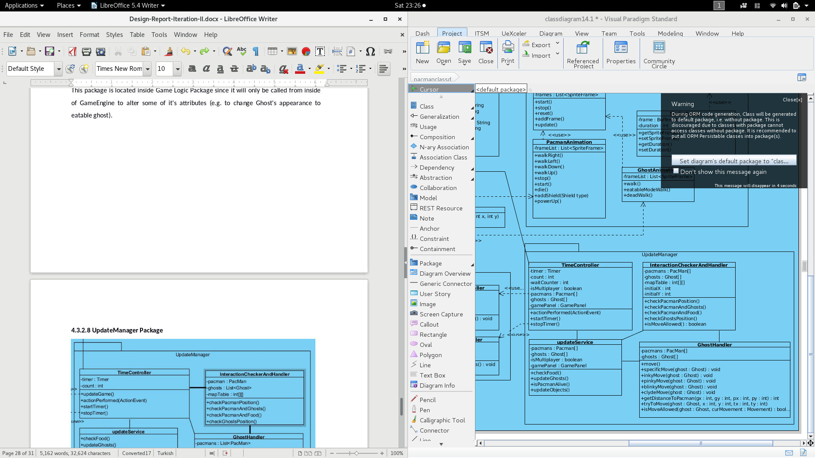

*Figure 5.8 – UpdateManager Package*

This package's services will be called each time the timer inside the TimeController class updates. It handles collisions between food and pacmans, pacmans and ghosts, moving objects and walls also current states of food ghosts and pacman(s).

**4.3.2.6.1 Tim­eController Class**

**Constructor:**

public TimeController(int[][] gameMap, ArrayList<Food> foods, Pacman[] pacmans, boolean isMultiplayer, Ghost[] ghosts, GamePanel gamePanel): Initializes each of its attributes to their default values.

**Attributes:**

private Timer timer; main timer of the game.

private int count; cycle counter, increases at every timer update, controlled panel times.

private int waitCounter; getReadyPanel present period in cycles.

private boolean isMultiplayer; is game multiplayer?

private Pacman[] pacmans;

private Ghost[] ghosts;

private GamePanel gamePanel;

private int[][] gameMap; game map skectc in the form of two dimensional array.

private ArrayList<Food> foods; foods in the game need to be present here and related classes to control the food interaction.

private UpdateService updateService; this object does the main job, it updates every single game element based on the timer cycles.

**Methods:**

public void startTimer(): Starts timer, initializes or sets waitCounter to 100 counts and presents the getReadyLabel inside the gamePanel object. Called when a game started or resumed.

public void stopTimer(): Only stops the timer object. Called when game needs a pause.

public void actionPerformed(ActionEvent arg0): this method is the overrided method of the interface of ActionListener. Gets called every time timer object updates. It checks counter and then acoding to that calls updateService objects updateObjects() method.

**4.3.2.9 InputManager Package**

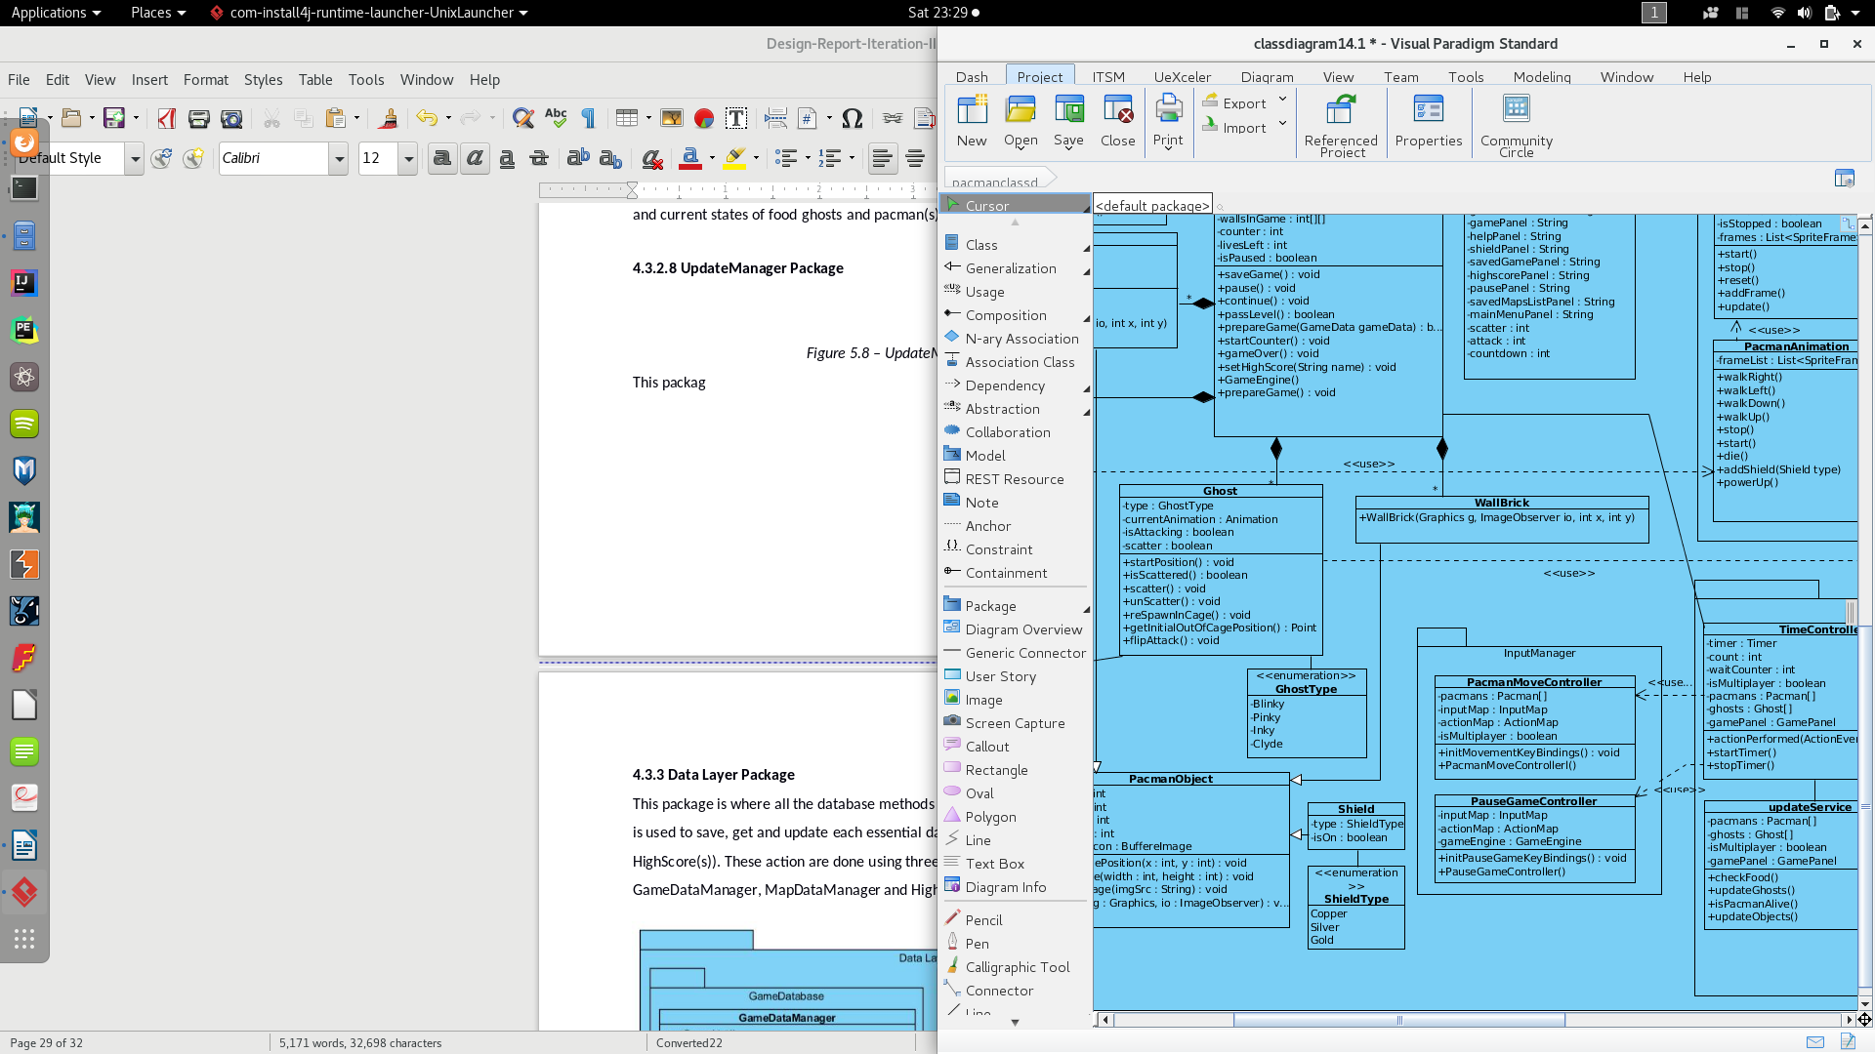

*Figure 5.9 – InputManager Package*

This package manages hardware inputs such as keyboard and mouse. PacmanMoveController receives keyboard inputs and keeps this data in its inputMap, it will listen arrow keys for firstPlayer and A,S,D,W keys for the second player if there is one, therefore it needs to check isMultiplayer attribute before deciding to listen to a specific keyboard symbol. It will update its version of pacmans, updateManager will make use of these Pacman instances to update actual Pacman objects belonging to GameEngine.

PauseGameController listens to mouse and keyboard inputs to see if player(s) has pressed a certain pause key or has clicked the pause button in the screen.

**4.3.3 Data Layer Package**

This package is where all the database methods and objects are handled. This packaged is used to save, get and update each essential data component (GameData, MapData, HighScore(s)). These action are done using three different manager classes : GameDataManager, MapDataManager and HighScoreDataManager.

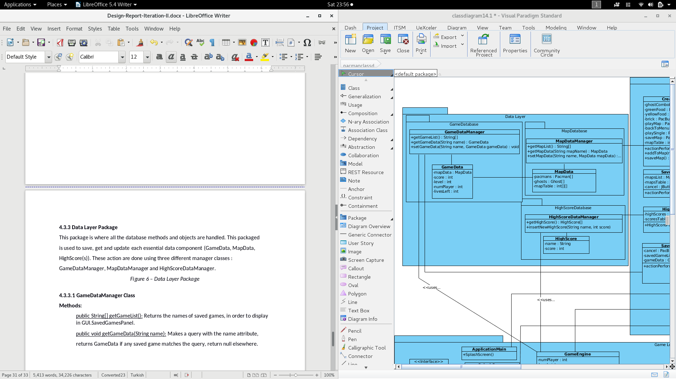

*Figure 6 – Data Layer Package*

**4.3.3.1 GameDataManager Class**

**Methods:**

public String[] getGameList(): Returns the names of saved games, in order to display in GUI.SavedGamesPanel.

public void getGameData(String name): Makes a query with the name attribute, returns GameData if any saved game matches the query, return null elsewhere. public void setGameData(String name, GameData gameData): This function is called when users try to save their game. It attaches this games name into name list and creates a separate file for this game's data.

**4.3.3.2 GameData Class**

**Attributes:**

protected MapData mapData: Keeps the map data of the game.

protected int score: Keeps the total score of the game

protected int level: Keeps the current level of the game.

protected int numPlayer: Keeps the number of players of the game

protected int livesLeft: Keeps total livesLeft of players of the game.

**4.3.3.3 MapDataManager Class**

**Methods:**

public String[] getMapList(): Returns the names of saved maps, in order to display in GUI.SavedMapsPanel.

Public MapData getMapData(String mapName): This function is called when user tries to load a user made map. Returns the MapData if the query matches with one of the previously made maps; else, returns null.

public void setMapData(String mapName, MapeData mapData): This function is called when users try to save a map. It attaches this map's name into a list of map names and creates a separate file for this map's data.

**4.3.3.4 MapData Class**

**Attributes:**

protected Pacman[] pacmans: Keeps the Pacman objects.

protected int score: Keeps the Ghost objects.

protected int[][] mapTable: Keeps a table for the rest of the screen objects, each type will be represented with a different integer, and each element in specific row and column will keep an integer (therefore a record of a object).

**4.3.3.5 HighScoreDataManager Class**

**Methods:**

public Highscore[] getHighScore(): Returns the list of highScore objects, each with a username and a score.

public void insertNewHighScore(String name, int score): Creates a HighScore instance and pushes it into the list of HighScores.